VIETNAM NATIONAL UNIVERSITY – HO CHI MINH CITY
INTERNATIONAL UNIVERSITY
SCHOOL OF ELECTRICAL ENGINEERING



FRUIT - HARVESTING ROBOT

BY
NGUYEN HOANG DANG KHOA - EEACIU22140
NGUYEN HOANG PHUC - EEACIU22157
HO NGOC HAI - EEACIU22156
LE TAN DUY - EEACIU22208
NGUYEN KHOI NGUYEN - EEACIU22144

ADVISOR: DR. PHAM TRUNG KIEN

HO CHI MINH CITY, VIETNAM, 2025

Under the guidance and approval of the committee, and approved by its members, this capstone report has been accepted in partial fulfillment of the requirements for the degree.

Approved:

______________________________
Chairperson

______________________________
Committee member

______________________________
Committee member

______________________________
Committee member

______________________________
Committee member

HONESTY DECLARATION

Our group’s name is 5TL with 5 members: Nguyen Hoang Dang Khoa, Nguyen Hoang Phuc, Ho Ngoc Hai, Le Tan Duy, Nguyen Khoi Nguyen. We would like to declare that, apart from the acknowledged references, this thesis either does not use language, ideas, or other original material from anyone; or has not been previously submitted to any other educational and research programs or institutions. We fully understand that any writings in this thesis contradicted to the above statement will automatically lead to the rejection from the EE program at the International University – Vietnam National University Hochiminh City.

Date:
Student’s Signature

ACKNOWLEDGMENT

It is with deep gratitude and appreciation that our group acknowledge the professional guidance of Dr.Pham Trung Kien. His constant encouragement and support helped our group to achieve a goal.

TABLE OF CONTENTS
HONESTY DECLARATION 2
ACKNOWLEDGMENT 3
TABLE OF CONTENTS 4
TABLE OF FIGURES 6
LIST OF TABLES 7
ABBREVIATIONS AND NOTATIONS 8
ABSTRACT 9
Chapter 1 Introduction 11
1.1. Issue 11
1.1.1. Outdated farming methods: 11
1.1.2. Human labor: 12
1.1.3. Workforce health: 13
1.1.4. Inefficient use of resources: 14
1.1.5. Climate change: 15
1.2. Problem statement 16
1.2.1. Poor productivity 16
Chapter 2 Standards and realistic constraints 19
2.1 Standards 19
2.2 Realistic Constrains 20
2.2.1 Economics 20
2.2.2 Physical 20
2.2.3 Environmental 20
2.2.4 Ethical 20
2.2.5 Reliability 20
Chapter 3 Literature review 22
3.1 RoamIO-HCW by Korechi 22
3.2 Design of a Four-Axis Robot Arm System Based on Machine Vision 23
3.3 Calibration solution for fruit detecting camera 24
3.4 Automated harvesting by a dual-arm fruit harvesting robot: 25
3.4.1 Target tree and fruit characteristics 25
3.4.2 Automatic fruit harvesting method 26
3.4.3 Fruit detection 27
3.4.4 Fruit localization 28
Chapter 4 Methodology 32
4.2 Objective 1 Design the robot 32
4.2.1 Task 1: Design the Chassis 33
4.2.2 Task 2: Design the Propulsion 33
4.2.3 Task 3: Design the Robotic Arm 34
4.2.4 Task 4: Design the control panel 36
4.2.5 Task 5 Combining the designs 36
4.3 Objective 2. Fabricating the robot 36
4.3.1 Task 1: Assemble the propulsion into the chassis 37
4.3.2 Task 2: Mount the robotic arm 39
4.3.3 Task 3: Mounting the camera 40
4.3.4 Task 4: Mounting the control panels, power supply and sensors 41
4.4 Objective 3 41
4.4.1 Task 1: Developing the navigating system 42
4.4.2 Task 2: Developing CPU for the robotic arm 44
4.4.3 Task 3: Developing fruit harvesting algorithm 44
4.4 Objective 4 Unit test and Integration test 45
4.4.1 Task 1: Unit test 45
4.4.2 Task 2: Integration test 46
Chapter 5: Preliminary results 47
5.1 Objective 1 Task 1: Design the Chassis 47
5.2 Objective 1 Task 2: Design the Propulsion 48
5.3 Objective 1 Task 3: Design the Robotic arm 49
5.4 Objective 1 Task 5: Combining the designs 50
5.5 Objective 2 task 1: Assemble the propulsion into the chassis 51
5.6 Objective 2 task 2: Mounting the robotic arm 52
5.7 Objective 3 task 1: Developing the navigation system. 52
5.8 Objective 3 task 2: Developing CPU for the robotic arm. 53

TABLE OF FIGURES
Figure 1: Vietnam - Employment In Agriculture (% Of Total Employment) in 12 years(2011-2022) 12
Figure 2: Water Withdrawals by Sector in Viet Nam 14
Figure 3: Vietnam's economic structure in early 2024 17
Figure 4: Cultivation progress in early 2022 18
Figure 5: RoamIO-HCW 22
Figure 6: 4-axis robot arm 23
Figure 7: Apple-harvesting robot 23
Figure 8: Fruit harvesting robot 24
Figure 9: Developer Kit. (a) Nvidia Jetson Nano (b) Imx 24
Figure 10: Camera calibration checkboard 25
Figure 11: Example of V-shape trellis 26
Figure 12: Flowchart of automatic harvesting 26
Figure 13: Image Annotation 27
Figure 14:Task Management 28
Figure 15: Algorithm 30
Figure 16: Denavit-Hartenberg parameter 31
Figure 17: System overview 32
Figure 18: TinkerCAD 33
Figure 19: RoamIO-HCW 34
Figure 20: 3D arm parts 34
Figure 21: GRABCAD's Solidworks design 35
Figure 22: Proteus 36
Figure 23: 20x20 Shaped aluminum 37
Figure 24: Motor mount 37
Figure 25: Rear swivel casters 38
Figure 26: Robotic arm 39
Figure 27: AI camera mounted in TinkerCAD 40
Figure 28: IR sensors for line follow 41
Figure 29: Robot’s power supply 41
Figure 30: Line follow model 42
Figure 31: Arduino IDE 42
Figure 32: Arduino MEGA2560 43
Figure 33: Arduino ESP32 44
Figure 34: Chassis 3D model in TinkerCAD 47
Figure 35: Robot's propulsion 48
Figure 36: 3D model of robotic arm 49
Figure 37: Full assembly in TinkerCAD 50
Figure 38: Propulsion assembly 51
Figure 39: Robotic arm 52
Figure 40: Line follow navigation 52
Figure 41: Yolo model test results 53

LIST OF TABLES
Table 1: Devices’ standards 19
Table 2: Realistic Constraints used in this project 20
Table 3: Table of Unit Tests 44
Table 4: Table of Intergration tests 45

ABBREVIATIONS AND NOTATIONS

RF: Radio frequency

ABSTRACT
Vietnam's agriculture remains relatively underdeveloped despite the country's abundant natural resources and potential for high productivity. This sector relies on traditional farming practices, leading to inefficiencies in production, low yields, and negative impacts on farmers' health. To address these challenges, this study focuses on modernizing Vietnam’s agriculture through the application of automation and robotics. By examining a Fruit - Harvesting robot developed by an Australian university, which uses a visionary system for precise detection and harvesting of ripe fruits, the study explores how automation can reduce the reliance on manual labor. This technology not only increases efficiency but also addresses occupational health and safety concerns in agriculture, improving the overall quality of produce. The findings suggest that the integration of robotics in farming practices can effectively modernize the industry, offering a solution to outdated methods.

Keywords: agriculture, traditional farming, modernizing, automation, robotics, Fruit - Harvesting robot.

Introduction

In this chapter, we would illustrate two major parts of the introduction to the status of agriculture in VietNam are the “Issue” and the “problem statement” - the problem that our team wanted to use FRUIT - HARVESTING ROBOT to improve.

Issue
In this part, we will indicate an overview of the issue of agriculture in VietNam and some main detail problems of it such as: “Outdated farming methods”, “Human labor”, “Workforce health”, “Inefficient use of resources” and “Climate change”.
Agriculture remains a vital part of Vietnam’s economy, employing a large percentage of the population and contributing significantly to exports. However, the sector faces multiple challenges. Outdated farming methods, combined with limited access to modern technology, result in low productivity for many small-scale farmers. Environmental concerns, such as soil degradation, overuse of pesticides, and water pollution, further exacerbate the situation.

Outdated farming methods:
Vietnam's agricultural sector is characterized by a significant reliance on outdated farming methods, which can hinder productivity and sustainability.
      - Traditional Practices:
Many farmers still employ traditional techniques that have been handed down through the centuries. Lower crop yields and production inefficiencies are the results of these techniques, which frequently entail human work and little use of technology. For example, the use of hand tools and simple irrigation systems may limit the capacity to scale output and successfully meet market demands.
      - Slow Adoption of Technology:
Despite a growing modernization trend, innovative agricultural technology is still not widely adopted, especially by smallholder farmers. Many people are unable to invest in contemporary machinery and procedures that could increase productivity and lower labor intensity due to financial limitations and limited financing availability.
      - Limited Crop Diversity:
A limited variety of staple crops are the focus of many farmers, which can deplete soil and make them more susceptible to pests and illnesses. In addition to having an impact on food security, this lack of diversity makes farming systems less resilient to the effects of climate change.
      - Need for Education and Training:
Programs that educate farmers about contemporary agricultural methods and environmental practices are desperately needed. In the end, training programs can improve farmers' lives and the sustainability of the agriculture industry by assisting them in switching from conventional techniques to more effective and ecologically friendly ones.

Human labor
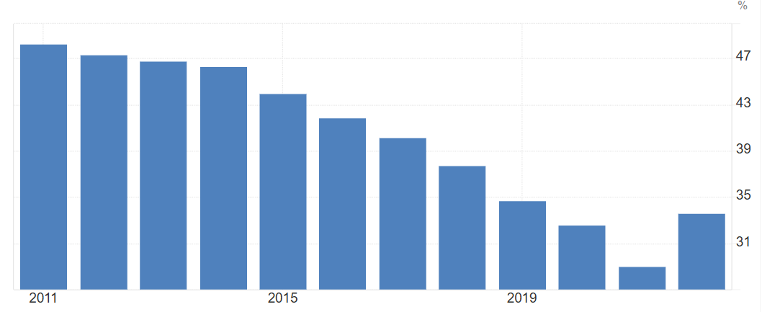
Figure 1: Vietnam - Employment In Agriculture (% Of Total Employment) in 12 years(2011-2022)
Vietnam's agricultural workforce faces a number of issues that affect sustainability and production. Employment in agriculture (% of total employment) (modeled ILO estimate) in Vietnam was reported at 33.61 % in 2022, according to the World Bank collection of development indicators, compiled from officially recognized sources.

      - Demographics of Labor Force:
Vietnam's agriculture industry still employs a sizable fraction of the labor population, but as more people move to cities in search of better employment prospects, the sector's share of the labor force is decreasing. The agricultural industry, which is highly dependent on a steady supply of workers, is at risk from this change.

      - Wage Issues:
There is a labor shortage in rural areas as a result of agricultural wages frequently being lower than those in urban sectors. The difficulties the agriculture sector faces in retaining a steady workforce are made worse by the fact that many workers are enticed to higher-paying occupations in cities.

      - Youth Participation:
Since younger generations choose to pursue more profitable and less labor-intensive work options in metropolitan environments, it is becoming more and more difficult to draw them to agriculture. Vietnam's farming industry faces a threat from this trend since an aging labor force may find it difficult to adopt new methods and technologies.

      - Working Conditions:
Long hours, exposure to dangerous materials, and insufficient safety precautions are just a few of the unfavorable working conditions that many agricultural laborers face. These elements have an impact on their general job happiness and productivity in addition to their health.

Workforce health:
The health of the agricultural workforce in Vietnam is a critical issue that requires attention.
The report from the Ministry of Labor, Invalids, and Social Affairs indicates that for every 100,000 rural workers, 799 experience electrical accidents, 856 suffer accidents related to machinery use, and 1,700 are affected by health issues caused by pesticides. Findings from research on injuries in Vietnam also reveal that the injury rate in agricultural labor is approximately 31 individuals per 1,000 people per year. When comparing the risk of injuries across different industries, farmers are identified as the second-highest group at risk. These figures highlight that injuries in agriculture are currently at an alarming level.

      - Health Hazards:
Workers in agriculture face numerous health hazards, prominently including exposure to pesticides and physically demanding labor. Prolonged exposure to hazardous chemicals can lead to chronic health issues, such as respiratory problems and skin conditions. Additionally, the physically taxing nature of agricultural work often results in musculoskeletal disorders, which can significantly impair workers' ability to perform their jobs. The combination of these factors not only affects individual health but also impacts productivity and the overall efficiency of the agricultural sector.

      - Healthcare Access:
Access to healthcare services in rural areas is frequently limited, posing a significant barrier for agricultural workers seeking timely medical attention. Many rural communities lack adequate healthcare facilities and trained professionals, making it challenging for workers to obtain necessary medical care. This lack of access can exacerbate existing health problems, leading to increased absenteeism from work and decreased overall well-being within farming communities. Furthermore, the financial burden of healthcare can deter workers from seeking help, resulting in untreated conditions that could have been managed with early intervention.

      - Nutritional Challenges:
Many farmers and their families face nutritional inadequacies due to low incomes and restricted access to diverse food sources. The economic pressures of farming often leave little room for investment in quality nutrition, which is essential for maintaining health and productivity. Malnutrition can lead to a range of health issues, including reduced energy levels and weakened immune systems, further impairing farmers' capacity to perform agricultural labor efficiently. Addressing these nutritional challenges is vital for improving the health and productivity of the agricultural workforce.

      - Mental Health Concerns:
The psychological well-being of farmers is another critical area that requires attention. The stresses associated with farming such as fluctuating market prices, unpredictable weather patterns, and financial instability can lead to mental health issues, including anxiety and depression. Unfortunately, mental health is often overlooked in rural health initiatives, depriving many individuals of the support they need. Implementing mental health programs and resources tailored to the agricultural community can help alleviate some of these pressures and promote a healthier workforce.

Inefficient use of resources:
Inefficient resource use is a significant challenge in Vietnam's agricultural sector, impacting sustainability and productivity.
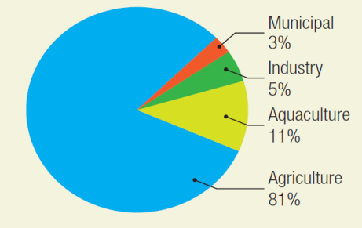
Figure 2: Water Withdrawals by Sector in Viet Nam

      - Water Usage:
Ineffective irrigation techniques employed by many farmers lead to substantial water wastage. Current practices often lack the precision and efficiency required to optimize water use, resulting in over-irrigation and runoff. To enhance agricultural sustainability, it is essential to adopt better water management practices, such as drip irrigation and rainwater harvesting. These methods can help conserve water resources while ensuring crops receive the necessary hydration for optimal growth.

      - Soil Management Issues:
The sustainability of agricultural output is further threatened by soil degradation, primarily driven by an over-reliance on chemical fertilizers and monoculture practices. These methods can deplete soil nutrients and diminish its overall health, leading to reduced crop yields over time. Transitioning to sustainable soil management techniques-such as crop rotation, organic fertilizers, and cover cropping-can restore soil health and improve long-term agricultural productivity.

      - Energy Inefficiencies:
Many farming operations continue to rely on traditional energy sources, which are often less efficient and more environmentally damaging than modern alternatives. The adoption of renewable energy sources, such as solar or wind power, could significantly enhance productivity while reducing the negative environmental impacts associated with conventional energy use. Investing in energy-efficient technologies can lead to cost savings for farmers and promote a more sustainable agricultural framework.

      - Resource Distribution:
Smallholder farmers frequently encounter difficulties accessing quality inputs like seeds and fertilizers, which hampers their agricultural performance. These barriers often stem from inadequate distribution networks and a lack of support services tailored to small-scale producers. Improving the distribution of resources and providing targeted support to smallholders are crucial steps toward enhancing productivity and sustainability in the agricultural sector. This could involve establishing cooperatives or partnerships that facilitate access to quality inputs and shared resources, thereby empowering smallholder farmers and promoting collective growth.

Climate change:
Climate change poses significant challenges for agriculture in Vietnam, impacting crop yields, increasing extreme weather events, and creating water management issues.
Impact on Crop Yields: The production of Vietnam's main crops, especially rice, which is essential for food security, is greatly impacted by climate change. Temperature increases have the potential to shorten the growth season and lower yields. According to studies, rice yields may decrease by 10% for every degree Celsius that the temperature rises. For areas like the Mekong Delta, where rice production is highly dependent on consistent weather, this is particularly worrisome.The production of Vietnam's main crops, especially rice, which is essential for food security, is greatly impacted by climate change. Temperature increases have the potential to shorten the growth season and lower yields. According to studies, rice yields may decrease by 10% for every degree Celsius that the temperature rises.

      - Increased Incidence of Extreme Weather:
Extreme weather events like droughts and floods have become more frequent and intense as a result of climate change. These occurrences cause major financial losses, interfere with planting schedules, and harm infrastructure in Vietnam. For example, millions of farmers experienced severe drought in the central and southern regions due to the 2016 El Niño phenomena, which resulted in several crop failures.

      - Water Scarcity and Management Challenges:
For Vietnamese farmers, water scarcity has become a major concern as temperatures rise and rainfall patterns shift. During dry seasons, the Mekong River, a vital supply of water for agriculture, experiences decreased flow. Farmers may argue over water use as a result of this shortage, which also makes irrigation more difficult. To adjust to these changes, effective water management techniques like rainwater collection and enhanced irrigation technologies are crucial.

      - Adaptation Strategies and Policy Responses:
In order to lessen the effects of climate change, Vietnam is implementing a number of adaptation measures. These include creating crop types that are robust to climate change, encouraging sustainable farming methods, and improving farmers' access to resources and knowledge. In order to assist these efforts, government policies are also changing, emphasizing research, funding climate-smart agriculture, and bolstering rural infrastructure.

Problem statement
In this part, we will present the problem statement of this issue which is “Poor productivity”. Besides that, our project - Fruit-harveting robot will be created to improve this problem.

Poor productivity

      - Limited investment:
The level of investment in agriculture and rural areas is still limited and scattered, not commensurate with the potential and contribution of the sector to the national economy, so the rural technical infrastructure still has many shortcomings, not meeting the development requirements, especially the technical infrastructure directly serving agricultural production. For example, Vietnam's irrigation system is assessed as ineffective, without a water quality measurement system, without a flow control system. As a result, water productivity is low (World Bank Group, 2016). Agricultural support services are also underdeveloped, especially post-harvest preservation and logistics. The agricultural processing and deep processing industries are underdeveloped, mostly small-scale, with outdated technology (Quyen Dinh Ha, 2017). That leads to low quality of agricultural products when exported, with small added value. Supporting the connection to form a production and distribution chain for key agricultural products still faces many difficulties (World Bank Group, 2016). The agricultural business system only focuses on a number of traditional or highly profitable sectors such as rice, rubber, coffee, pepper, and cashew. Although "agricultural product trading floors" have been established, their operations are still very limited and not substantial (Nguyen Thi Minh Hien, 2016).

Due to the ineffective policy mechanism to attract investment in agriculture along with the fragmented land situation, there are still not many enterprises investing in high-tech agricultural production. The number of enterprises investing in the agricultural sector currently accounts for only 8% of the total number of enterprises nationwide, of which the number of enterprises directly investing in agricultural, forestry and fishery production accounts for only about 1%.

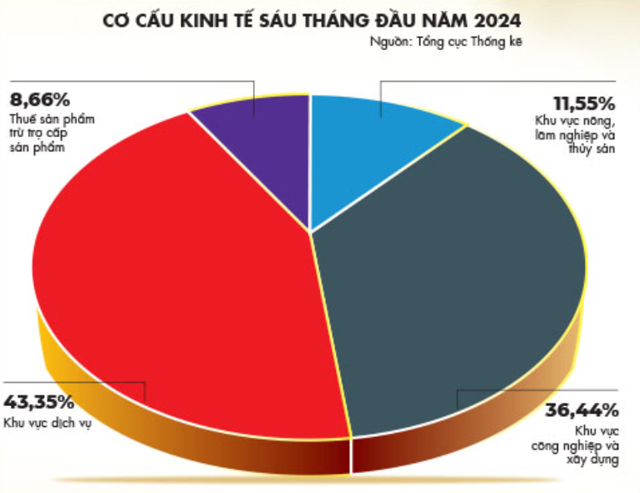
Figure 3: Vietnam's economic structure in early 2024

      - Slow innovation in household production model:
The main form of agricultural production organization in Vietnam is the household, accounting for 90% of the total agricultural production area (World Bank Group, 2016). In recent years, the household economy has been effective, but has also reached the ceiling of the trend of extensive development. Households have not focused on investing in increasing value, finding markets, and only producing what they have without following market signals. Obviously, the household economy is still and will always be the core of the rural economy, but it is in great need of being raised to a new level, a new position. Unfortunately, the current household economy is basically still what farmers have had since the post-renovation period, after Contract 10; there has not been any research that has shaped the portrait of the household economy in the era of Industry 4.0.

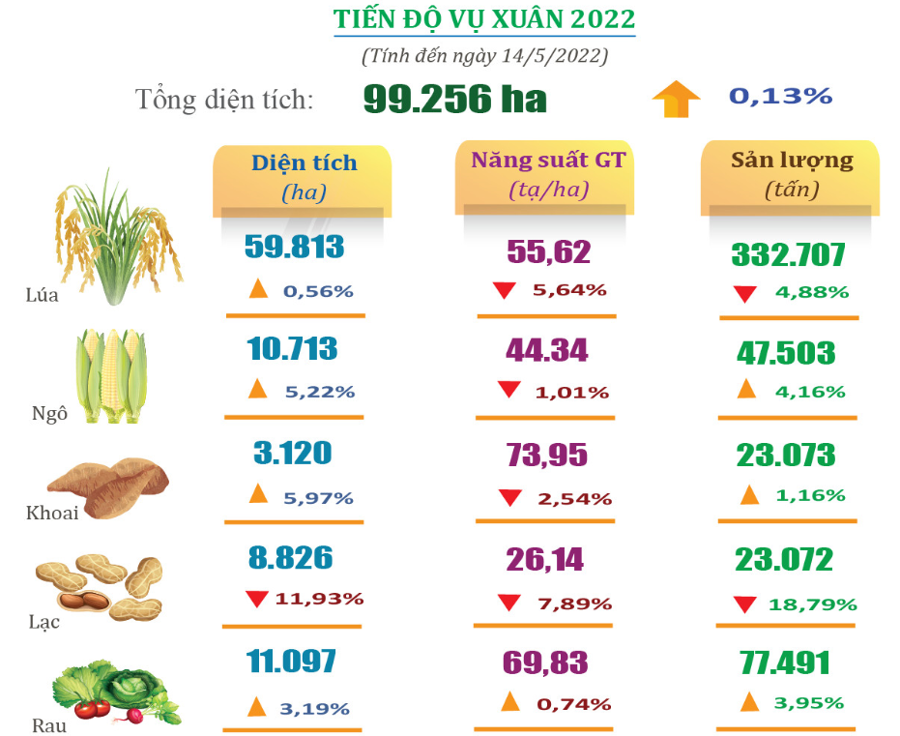
Figure 4: Cultivation progress in early 2022

      - Farmers' economic life:
Recent survey data show that although the rural landscape has changed a lot, the income and living standards of most farmers have improved but are still low, the income increase in the period 2002-2016 of farming households reached 5.75%/year, meaning that rural income increased over time but at a slow rate, while spending also increased, so the actual accumulation capacity of rural households is very low, the highest year only reached over 22 million VND, less than 50% of urban households. The poverty rate in rural areas is 3.7 times higher than in urban areas, 40% of rural households have no savings, 84% of agricultural workers have no savings (Khoi & Thang, 2019); in which, purely agricultural households have the lowest income, households purely working in agriculture, forestry and fishery have an income/month/person equal to 29% of the income/month/person in rural areas, just slightly higher than the group of people who do not work! Although the poverty rate has decreased rapidly, it is not sustainable, and the rate of re-poverty is high. With such financial resources, it is very difficult for farmers to invest in expanding production, improving their skills, or coping with price shocks or weather and disease disasters.
Besides that, it is worth noting that the trend of migration out of rural areas is strong, but the absolute number of households living in rural areas continues to increase. Farmers are shifting their livelihoods towards reducing the proportion of agriculture, but the rate of informal employment is very high, about 55% in 2016. The rate of dependent elderly people (aged 65 and over) accounts for more than 10% of the total rural population and will continue to increase along with the return of millions of workers from industrial zones to rural areas due to the impact of the fourth industrial revolution, which is likely to be a significant burden on rural development

Standards and realistic constraints
In this chapter, we will provide the standards and realistic constraints that were employed in this Thesis project, as well as the hardware and software that was used.

Standards
- ASME Standards (American Society of Mechanical Engineers)
  - ASME Y14.46
- ISO Standards (International Organization for Standardization)
  - ISO 9001
- IEEE Standards (Institute of Electrical and Electronic Engineering)
  - Connector IEEE 1394
  - IEEE P2936
  - Standards for electric power systems: IEEE 1547, IEEE 2030

Table 1: Devices’ standards
Device | Standards
Robot chassis | ISO 9001, ASME Y14.46
4-axis robotic arm | ASME Y14.46, ISO 9001, IEEE 1394
12V Lithium batteries | IEEE 1547, IEEE 2030
YDlidar X3 | IEEE 1394, IEEE P2936
Arduino ESP320 | IEEE 1394, IEEE 1547, IEEE 2030
JetsonNano | IEEE 1394, IEEE 1547, IEEE 2030

Realistic Constrains

Economics
- Cost: <15 million VND

Physical
- Size: 580mm x 350mm x 550mm
- Weight: <15kg

Environmental
- Noise pollution: <65dB
- Soil pollution: Product causes soil compaction.

Ethical
- The robot’s design implicitly uses patent protected designs/concepts from the Korechi company and other research papers

Reliability
- General performance: The robot’s performance will be affected by weather conditions (rain, wind), dense foliage, environmental factors (dust, debris, extreme temperatures).
- Software performance: The robot’s harvesting algorithm will struggle with fruit variability.
- Cross-terrain performance: Robot’s mobility struggles in soft terrain.

Table 2: Realistic Constraints used in this project
Realistic Constraints | Specifications
Economic: Cost | < 15 million VND
Physical: Size | Length: 580mm, Width: 350m, Height: 550mm
Physical: Weight | <15kg
Environmental: Noise pollution | <65dB
Environmental: Soil pollution | Soil compaction
Ethical | Uses patented designs/ideas from the Korechi company and other research papers
Reliability: General performance | Affected by weather conditions, dense foliage, environmental factors
Reliability: Software performance | Algorithm struggles with fruit variability
Reliability: Cross-terrain performance | Struggles in soft terrain

Literature review

In this chapter, our group will investigate four papers on the subject matter. To solve the issue of automation in agriculture, companies and groups have created solutions to integrate technology into agriculture. Technologies like IoT, Artificial Intelligence, robots, and drones were implemented to increase productivity, reduce human labor, and improve workforce health. The first research is “RoamIO-HCW” by Korechi from Canada along with related press articles. The second research is on the design of the 4-axis robot arm. The third and last research is on the camera calibration and software section of the "Fruit Harvesting robot" thesis by Pham Van Chinh, Pham Manh Tuan, Bui Thanh Lam.

3.1 RoamIO-HCW by Korechi

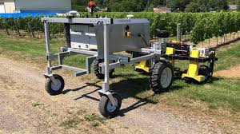
Figure 5: RoamIO-HCW

Korechi is a company that specializes in robotics and automation, their technologies are used in the agriculture sector and garden care. The company have created many agricultural robot models, the model that regard this research will be the RoamIO-HCW model. This agricultural robot boasts a robust design, featuring a powder-coated welded steel tube chassis with a stainless steel cover for durability and weather resistance. It utilizes 27" R1 agricultural lug tires for traction and 16.5" swivel casters for maneuverability. The robot has a compact footprint of 74" x 70.5" - 83.5" x 64" and weighs 1300 pounds. It offers a generous ground clearance of 32 inches and an adjustable width between 47.5" and 75.5" for versatility in different field conditions. Powered by 13.4 hp brushless DC motors with a peak output of 22.2 hp, the robot can reach a maximum speed of 4 mph. For safety, it incorporates a dual-camera collision avoidance system using artificial intelligence, along with both physical and remote emergency stop capabilities. The robot is equipped with a long-lasting 20 kWh lithium battery, ensuring continuous operation for over 10 years. Accurate positioning is achieved through multi-constellation multi-band GNSS RTK with dual antennas, enabling cm-level precision.A multi-purpose, autonomous robot that can perform many repetitive or unsafe task in place of humans can solve many productivy, labor and health problems.

3.2 Design of a Four-Axis Robot Arm System Based on Machine Vision
Four-axis robotic arms are becoming increasingly popular in industrial settings because of their reliable construction, simple upkeep, and flexibility. However, traditional systems are hindered by their rigid design, high software and hardware integration, and limited intelligence, leading to high production costs and energy consumption. The paper by Yijie Wang, Yushan Zhou, Lai Wei, Ruiya Li introduces an embedded design for a four-axis manipulator system that incorporates vision guidance to address these limitations.15
The primary structure was fabricated using 3D printing. Subsequently, the key components were assembled and tested. Unlike traditional gear-driven systems, the robotic arm leverages pulleys and idler pulleys, significantly enhancing system stability.15
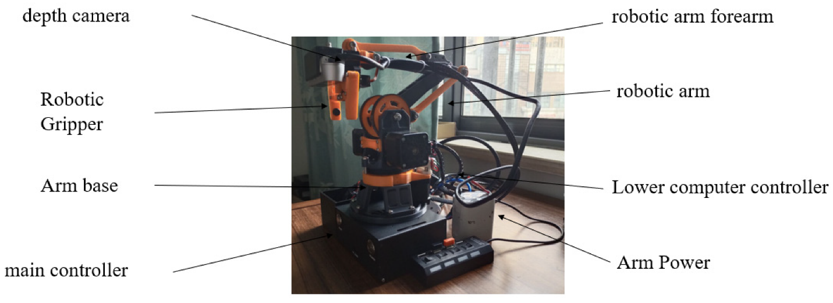
Figure 6: 4-axis robot arm

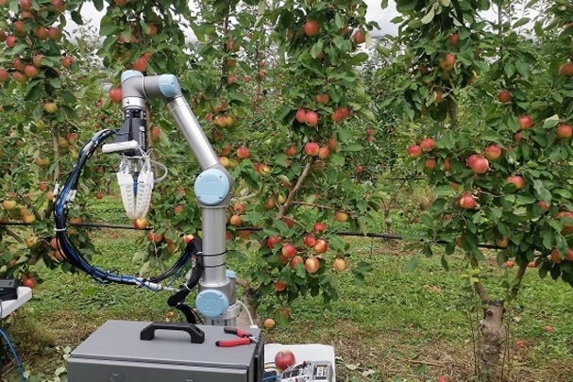
In 2021 a research team, led by Dr Chao Chen in Monash University’s Department of Mechanical and Aerospace Engineering, developed an autonomous apple harvesting robot capable of identifying, picking and depositing apples. The robot uses a 4-axis robot arm that’s pneumatically powered.14

Figure 7: Apple-harvesting robot
Multiple field trails have been conducted by the team in 2021, reports show that the robot damaged less than 6% of its haul by inadvertently removing their stems. While running the robot on half speed the harvesting rate was around 12.6 seconds an apple, while at max capacity harvesting time is reduced to as little as 7 seconds an apple.14

Our research will implement the design of the 4-axis robotic arm mentioned by the author.

3.3 Calibration solution for fruit detecting camera

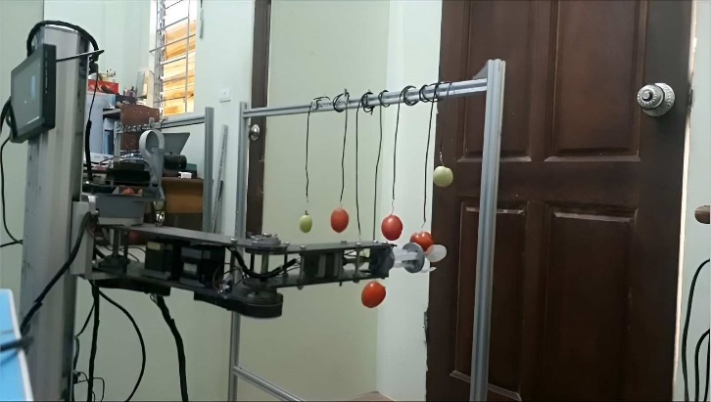
Research by Mr. Pham Minh Thang and others, was conducted to create an autonomous fruit-harvesting robot. The system utilizes a four-axis robotic arm and a computer vision system to identify and pick fruit. The robotic arm is controlled by an Arduino microcontroller, and the computer vision system employs an NVIDIA Jetson Nano and a high-resolution camera. The system analyzes images using color features and OpenCV algorithms to identify fruit and determine optimal picking locations. Experimental results demonstrate the system's effectiveness in accurately and efficiently harvesting fruit. 16

Figure 8: Fruit harvesting robot

For image processing, the robot uses the NVIDIA Jetson Nano Developer Kit, a small but powerful computer. For high resolution images, the IMX477 camera is used as it offers large amounts of pixels per area. 16

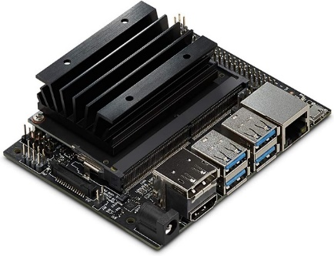  (a) | 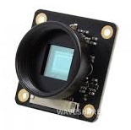  (b)
Figure 9: Developer Kit. (a) Nvidia Jetson Nano (b) Imx

The process of converting images from zero to image space often gives undesirable results because they are not high-quality and are often distorted. The camera is calibrated by capturing images of a checkerboard pattern from various angles. This process determines the camera's internal parameters, which are then used to rectify image distortion. The checkerboard in Figure 6 helps assess the extent of image curvature, which can manifest as either a convex or concave distortion. 16

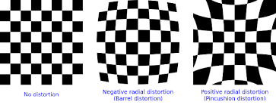
Figure 10: Camera calibration checkboard

Radial distortion causes light rays to bend more at the edges of a lens than at its center. This distortion is more significant in smaller lenses. The radial distortion coefficient quantifies this effect. Distorted pixel coordinates (xD, yD) related to undistorted coordinates (x, y) using the following equations (Eq.1):
$$x_{D}=x(1+k^{1}r^{2}+k^{2}r^{4}+k^{3}r^{6}) \\ y_{D}=y(1+k^{1}r^{2}+k^{2}r^{4}+k^{3}r^{6})$$Where:
- x,y: Pixel coordinate are not distorted.
- k1,k2,k3: Radial distortion coefficient of glazing system.
- $r^{2}=x^{2}+y^{2}$
Equation 1

Our research will utilize high resolution cameras, powerful image processing computers and the method of camera calibration that the thesis’s author suggested.

3.4 Automated harvesting by a dual-arm fruit harvesting robot: 17

3.4.1 Target tree and fruit characteristics
Through the research, the author determined that a densely lined V-shaped cultivation system, which making the fruit-bearing zone, can deliver the higher operational efficiency for the harvesting robot than the others.
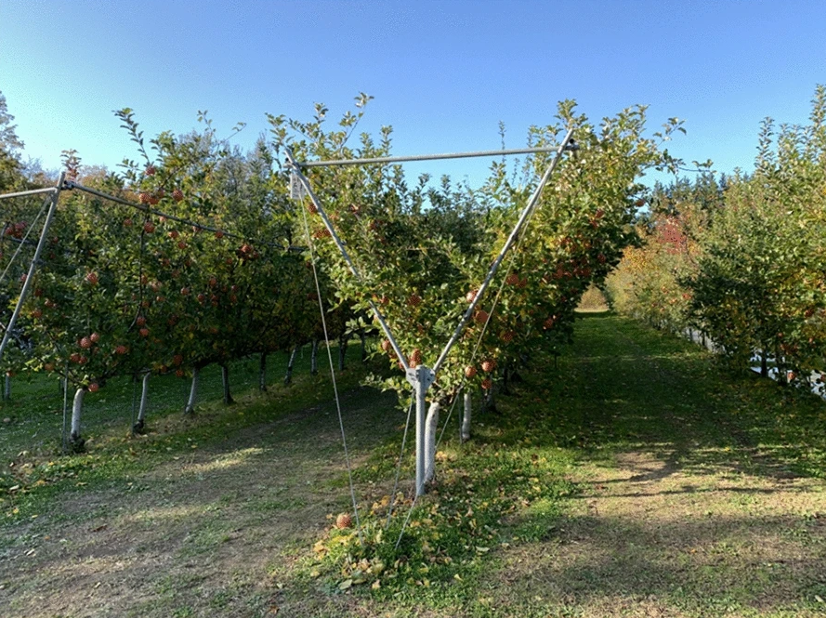
Figure 11: Example of V-shape trellis

3.4.2 Automatic fruit harvesting method

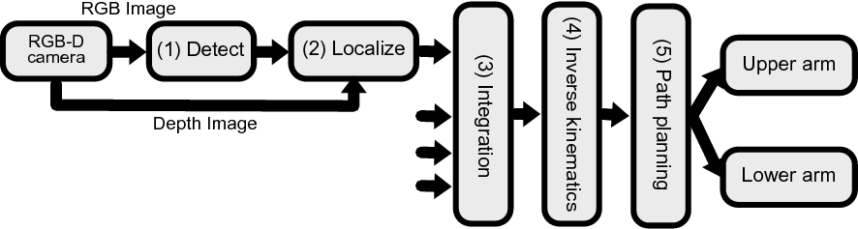
Figure 12: Flowchart of automatic harvesting
Figure 19 shows a flowchart of the basic working principle of automatic fruit harvesting:
      - Fruit detection
      - Fruit localization
      - Integration of information from camera
      - Inverse kinematics
      - Path planning

In the first step, RGB-D detects and locates the fruit in images by taking the RGB and depth information. Deep learning is performed on the RGB image acquired from RGB-D camera to detect the position of fruits in the image. By combining the position of the fruit from RGB and the depth images, the 3D position of them will be specified. In the next step, all of the information from cameras will be integrated, sorted and Ded by using Inverse kinetic. From that, the automatic harvesting robot can get the required information about the exact angle for each point (if there is an articulated robot arm). Finally, a robot will plant the path and start harvesting.

3.4.3 Fruit detection
To have the high accuracy, the RGB images, which are collected from RGB-D cameras, have to get some required information such as color and texture. After combing the information, the author apply the one of the object detection algorithms, which is Single Shot Multibox Detector (SSD), to detect fruits in images. It uses a single neural network, and was propose by Liu et al.
Besides that, there are various methods to detect an object:
- Faster R-CNN
- You Only Look Once (YOLO)
In the research, Single Shot Multibox Detector (SSD) is in the first priority because of the importance of the speed and the accuracy.
Equation 2:
$D=\left[δ_{1}… δ_{n}\right]$
Equation 3:
$$δ={[x_{min} x_{max} y_{min} { y}_{max}]}^{T}$$
Where:
- $D$: Bounding box information
- $δ$: One bounding box information
- $x_{max},{ y}_{max}$: The position of the lower right corner
- $x_{min},{ y}_{min}$: The position of the upper left corner
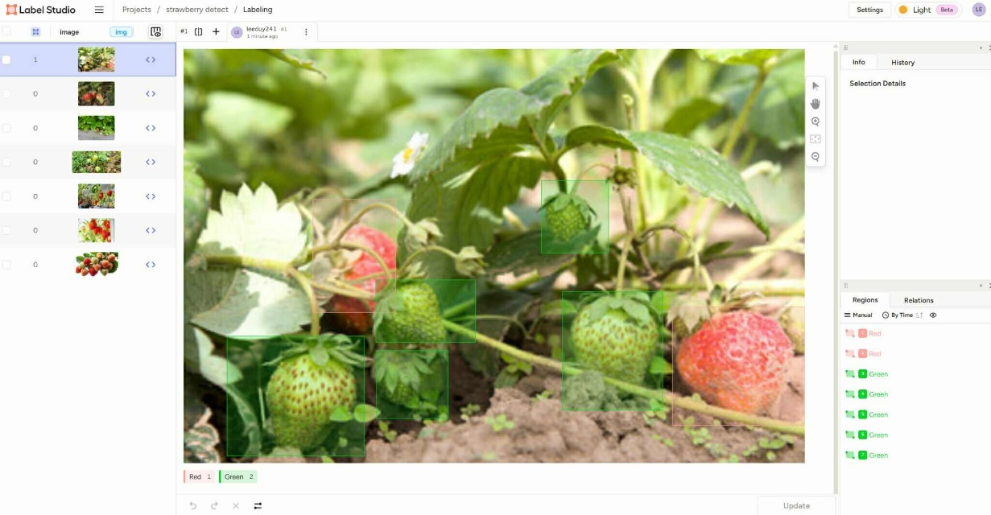
Figure 13: Image Annotation
- An image is loaded.
- Multiple strawberries are identified and marked using bounding boxes.
- Labels "Green" and "Red" are applied based on the ripeness of the strawberries.
- The right panel shows the annotation details (regions created and labeled manually).

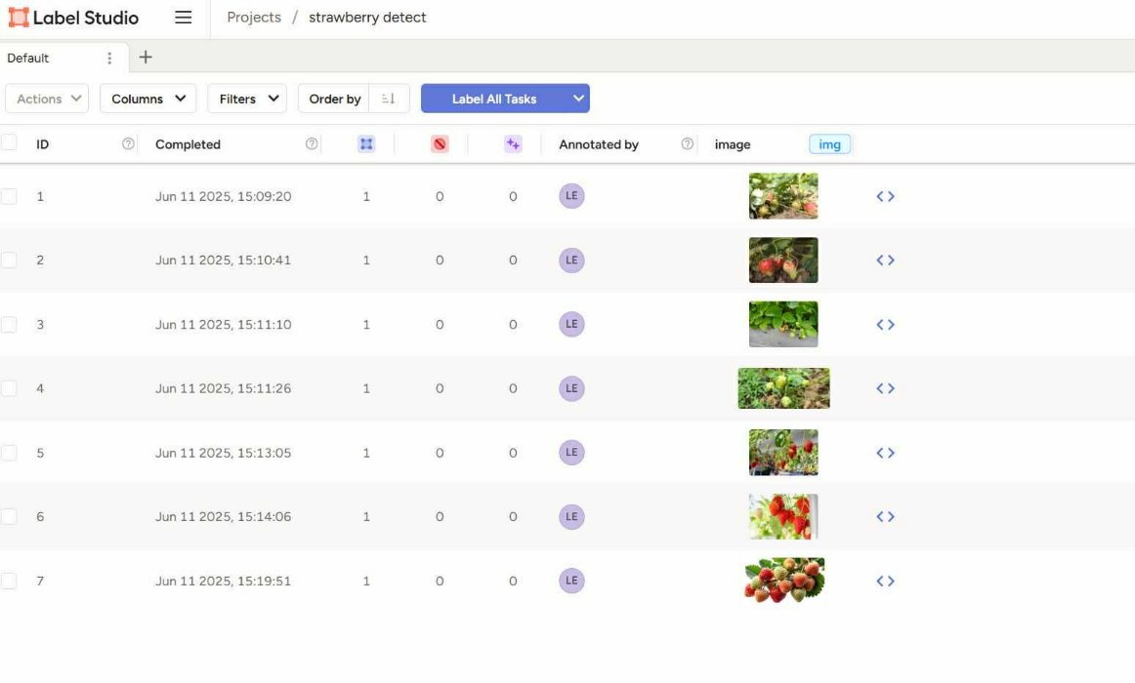
Figure 14:Task Management
- Shows a list of all image labeling tasks.
- All tasks are marked as Completed.

3.4.4 Fruit localization
In this step, the fruit can be considered as a sphere with the radius and the coordinate are calculated approximately from the bounding box information $δ$ in the previous part.
Especially, The Hough transform for circle detection is used in Fruit localization step to detect fruit circle from RGB images.

The relationship between the point in 3D $\left(X_{camX},Y_{camY},Z_{camZ}\right)$ space and the point (x,y) in 2D can be express in Equation 4:
Equation 4:
$$ⅆ\left[\begin{aligned}x \\ y \\ 1\end{aligned}\right]=\left[\begin{matrix}f_{x} & 0 & C_{x} \\ 0 & f_{y} & C_{y} \\ O & 0 & 1\end{matrix}\right] \left[\begin{aligned}X_{camX} \\ Y_{camY} \\ Z_{camZ}\end{aligned}\right]$$
Where:
- $f_{x},f_{y}$: the local length of camera
- $c_{x},c_{y}$: The image center of the camera
- $d$: the depth information at (x,y)
The rotation and translation matrices T between each robot arm and the camera coordinate system are used to transform the coordinate to robot arm:
Equation 5:
$$\left[\begin{aligned}\begin{aligned}X_{camX} \\ Y_{camY} \\ Z_{camZ}\end{aligned} \\ 1\end{aligned}\right]=T\left[\begin{aligned}\begin{aligned}X_{camX} \\ Y_{camY} \\ Z_{camZ}\end{aligned} \\ 1\end{aligned}\right]$$
The reciprocal of the pixel distance from the center of the circle detected to the center of the image is found by the Equation 6:
Equation 6:
$$s=\frac{1}{{\left(\frac{w}{2}-c_{x}\right)}^{2}+{\left(\frac{h}{2}-c_{y}\right)}^{2}}$$
Where:
- W: the width of the image
- h: The height of the image
The edge of the image of the fruit can get a large deviation in sphere detection due to the lack of RGB and depth information. As a result, the camera, which is nearest to the center of the image will be given priority.

The information L for all fruit, which can be demonstrated in Equation 5 and Equation 6, will be combined in equation 7:
Equation 7:
$$L=[σ_{1…}σ_{n}]$$
Equation 8:
$$σ={\left[ \begin{matrix}X_{arm} & Y_{arm} & Z_{arm }\end{matrix}\begin{matrix}R & s\end{matrix}\right]}^{T}$$
Where:
- $σ$ : the information of one fruit
- $\begin{matrix}{(X}_{arm} & Y_{arm} & Z_{arm }\end{matrix})$: The position of the fruit in the robot arm coordinate system
- R: The radius of fruit
- s: The score

3.4.5 Integration fruit
By the Algorithm 1, the integration step can match the number of fruit in the camera information with the actual number of fruits without duplication.
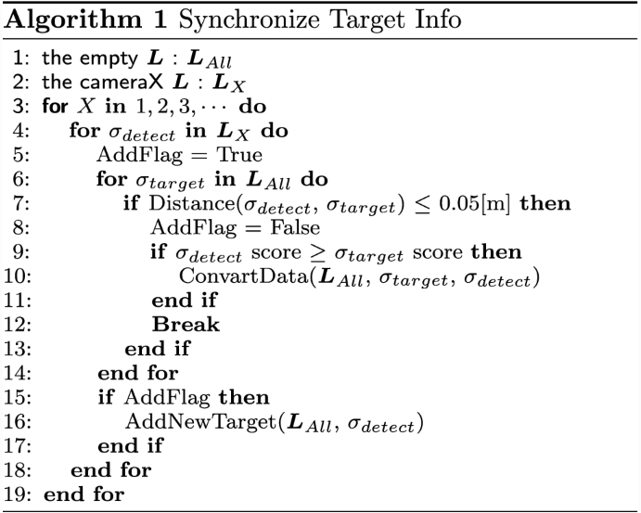
Figure 15: Algorithm
If the distance between the X coordinates of different fruits σi and σi+1 on the same branch is less than a threshold, the lower fruit will be harvested first.

3.4.6 Inverse kinetics
Through the research, it gives the information that Inverse kinetic is more complex than forward kinetic because it may have multiple or no solution for a given pose. Inverse kinematics is used to calculate the required angles for each point of the arm. In this process, the author finds the joints angle (q) from a given end-effector pose (P) through nonlinear function and the Denavit-Hartenberg notation.
Equation 9:
$$q=f^{-1}(P)$$
There are two types of solutions of inverse kinetic problem:
- Using iterative algorithms to find numerically
- Using the feature of the mechanism to obtain geometrically or algebraically
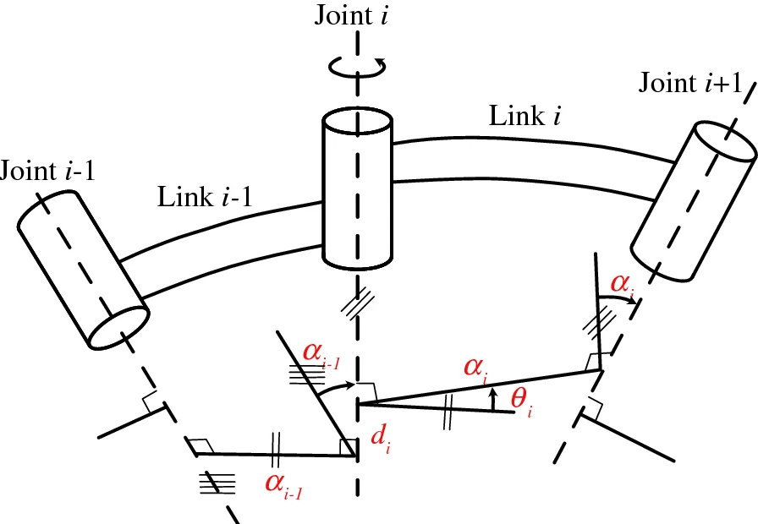
Figure 16: Denavit-Hartenberg parameter
Equation 10:
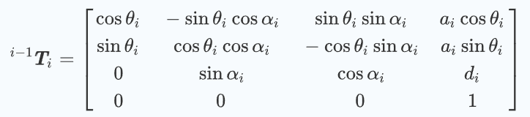

Chapter 4 Methodology
In this chapter, we will present the process of Designing and fabricating the autonomous fruit-harvesting robot using AI. To achieve this goal, we have 4 objectives. Objective 1 is Design the Robot. Objective 2 is Fabricating the robot. Objective 3 is Develop the robot’s CPU. Objective 4 is Test the robot. See figure 17 for the system overview of our study.

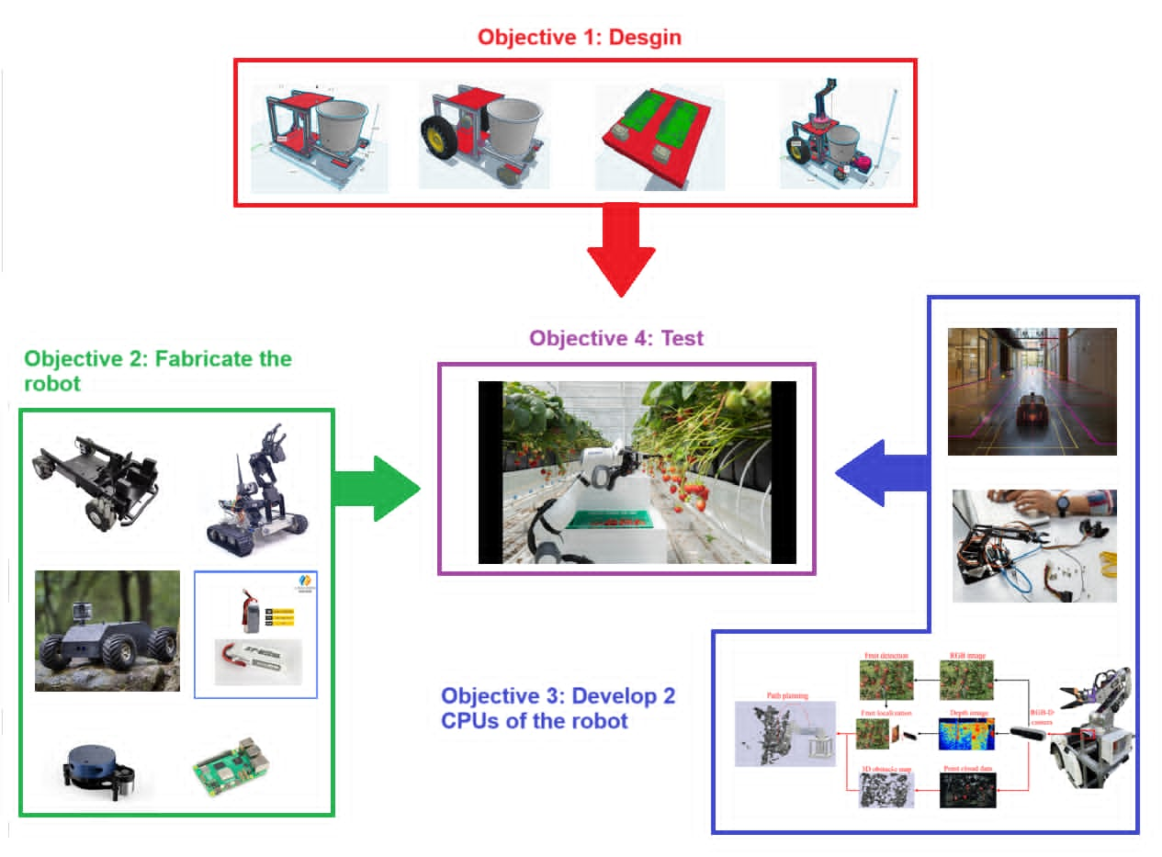
Figure 17: System overview

4.2 Objective 1: Design the robot
In the first objective, we have 4 tasks. Task 1 is Design the Chassis. Task 2 is Design the Propulsion, Task 3 is Design the Robotic arm. Task 4 is Combining the Designs.

4.2.1 Task 1: Design the Chassis
The first task of objective 1 is to design the robot’s frame (chassis), we will do so with the 3D design tool “TinkerCAD.

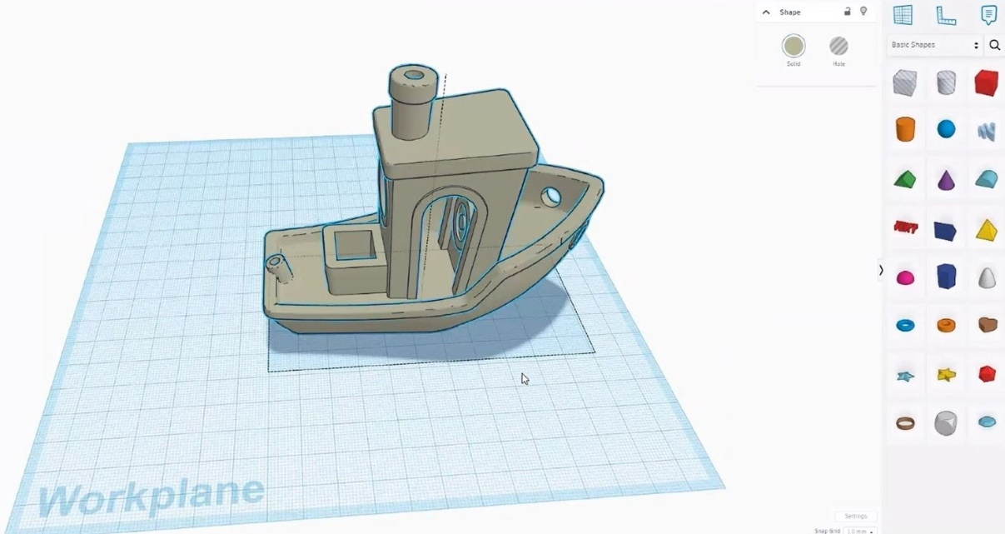
Figure 18: TinkerCAD

The task is completed when unit test 1 is done. The unit test 1 is done when all members of the team approve of the design.

4.2.2 Task 2: Design the Propulsion

The second task of objective 1 is to design the robot’s propulsion. We’ll based our design on RoamIO-HCW, see figure 20, to design our robot. The propulsion consists of 2 traction wheels powered by 2 motors independently and swivel casters for maneuverability12. We will stretch 3D models of the wheels and motors then attach them onto the chassis using TinkerCAD to design the 3D model, see figure 19.

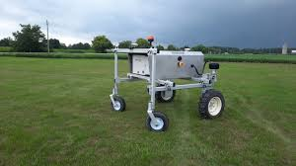
Figure 19: RoamIO-HCW
The task is completed when the unit test 2 is done. The unit test 2 is done when all members of the team approve of the design.

4.2.3 Task 3: Design the Robotic Arm
The third task of objective 1 is to design robotic arms. We’ll based our design on “4-axis robot arm” 13, see figure 4, to design our robotic arm. The arm consists of arm shanks, 3 step motors, rotary gears, a base and a parallel gripper. We’ll use TinkerCAD to design the 3D model, see figure 19. First, we’ll stretch and import all 3D models of the 4 DOF robot arm parts, see figure 21. Then we’ll assemble its components according to GRABCAD’s Solidworks design, see figure 22.

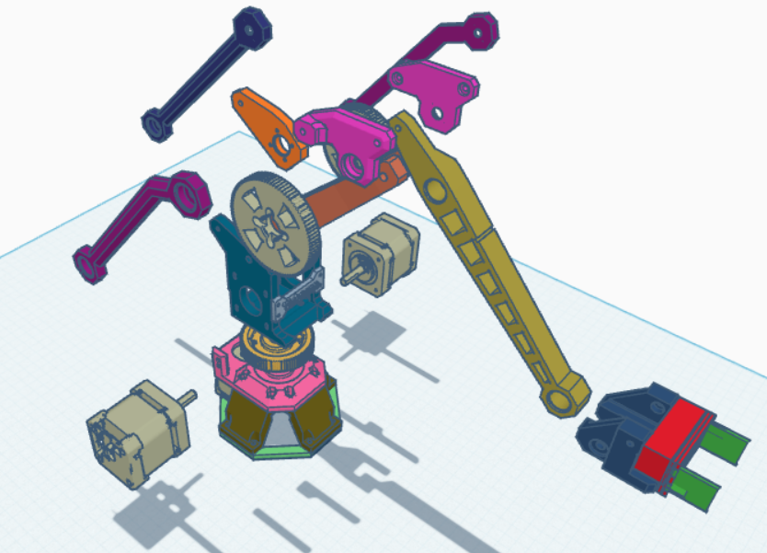
Figure 20: 3D arm parts

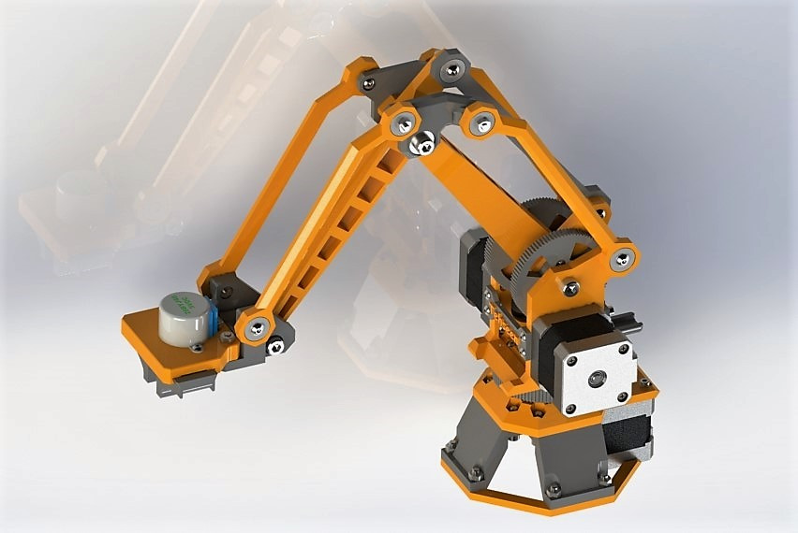
Figure 21: GRABCAD's Solidworks design

The task is completed when the unit test 3 is done. The unit test 3 is done when all members of the team approve of the design.

4.2.4 Task 4: Design the control panel
In this task, we design the control panel. The control panel includes 2 CPUs, LEDs and switches. The first CPU is used to control the robot’s propulsion. The second CPU is used to control robotic arms. The switches are for turning the CPUs on and off. LEDs will be used to indicate CPUs status (on or off). To design the board, we will use Proteus, see figure 23. We will install the 2 CPU’s library on Proteus and wire all components appropriately.
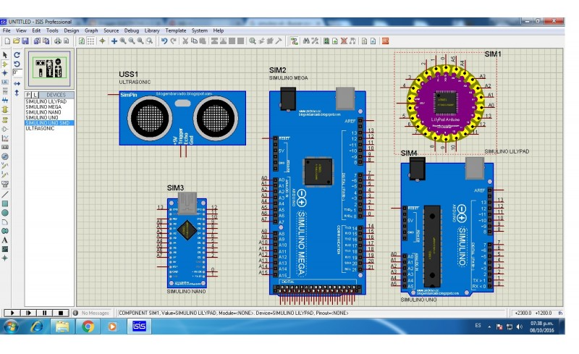
Figure 22: Proteus
The task is completed when the unit test 4 is done. The unit test 4 is done when all members of the team approve of the design and the circuit operates correctly.

4.2.5 Task 5 Combining the designs
The final task in objective 1 is to combine each designed components from task 1,2,3 into one unit.

The task is completed when the unit test 5 is done. The unit test is done when all members of the team approve of the design.

4.3 Objective 2: Fabricating the robot
In this section we’ll fabricate the robot. Objective 2 consists of 4 tasks. Task 1 is Assemble the propulsion to the chassis. Task 2 is Mount the robotic arm. Task 3 is Mount the AI camera. Task 4 is Mount the control panels, power supply and Lidar.

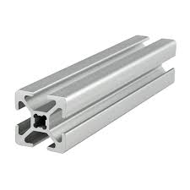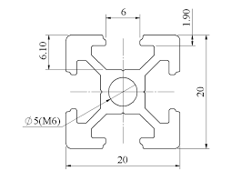
Figure 23: 20x20 Shaped aluminum

4.3.1 Task 1: Assemble the propulsion into the chassis
In the first task of objective 2, motors will be mounted to a motor base, see figure 24, and attached to the chassis. The front wheels will be attached to the motors. The rear swivel caster, see figure 25, will be attached to the rear 2 aluminum bars.

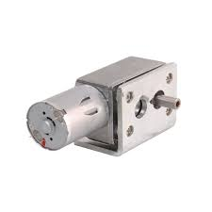
Figure 24: Motor mount

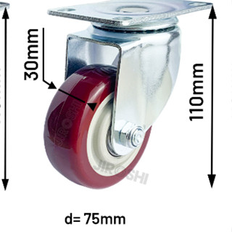
Figure 25: Rear swivel casters

The task is completed when the unit test 6 is done. The unit test is done when the 2 motors can propel the chassis, and the swivel casters can maneuver the chassis freely.

4.3.2 Task 2: Mount the robotic arm
In the second task of objective 2, the robot arm will be assembled and mounted on top of the chassis and be secured by bolts.

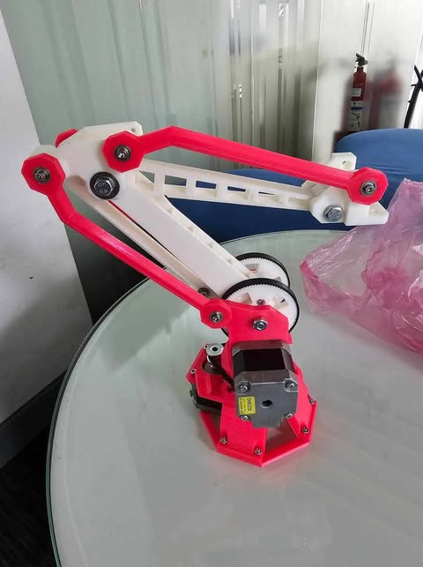
Figure 26: Robotic arm

The task is completed when unit test 7 is done. The unit test is done when the robot can is securely mounted on the chassis and can move freely.

4.3.3 Task 3: Mounting the camera
The third task is to mount the HuskyLens AI camera on the Robotic arm. A special mount will be attached to the robotic arm’s gripper, allowing the AI camera to be riveted tightly.

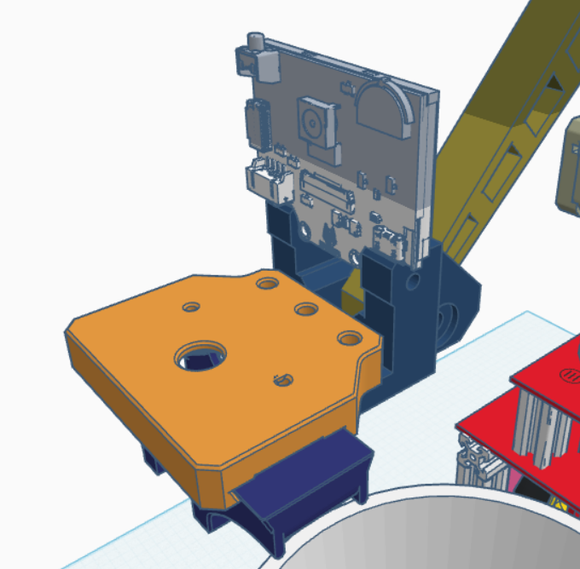
Figure 27: AI camera mounted in TinkerCAD

The task is completed when the unit test 8 is done. The unit test is done when the camera is attached securely, has a clear line of sight and be turned on by a power source.

4.3.4 Task 4: Mounting the control panels, power supply and sensors
The fourth task of objective 2 is to mount the power supply, control panels and FC51s. The power supplies are 3 Li-Ion 12V batteries, see figure 29, they are to be mounted near the motors for easy access. The control panel will be mounted within the chassis. The FC51s, see figure 28, will be attached to the front of the frame and be connected to the Arduino Mega.

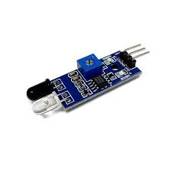
Figure 28: IR sensors for line follow

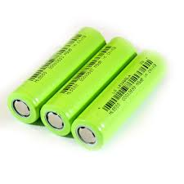
Figure 29: Robot’s power supply
The task is completed when the unit test 9 is done. The unit test 9 is done when the FC51s, CPU and power supply are connected and powered.

4.4 Objective 3: Firmware development
In this section, we’ll develop the 2 CPUs of the robot. The objective involves the tasks of “Developing the navigating system”, “Developing the CPU for the Robotic arm” and “developing the fruit harvesting algorithm”

4.4.1 Task 1: Developing the navigating system
The first task of objective 3 is to develop a navigating system for the Propulsion utilizing multiple FC51 IR sensors. Programming will be done on Arduino IDE, see figure 33, and be imported into an Arduino MEGA 2560, see figure 34. The program will be based on a “Line follow” algorithm that uses PID controller stabilize the robot’s movement in a straight path along crop row.

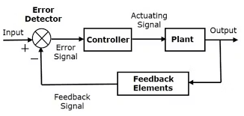
Figure 30: Line follow model

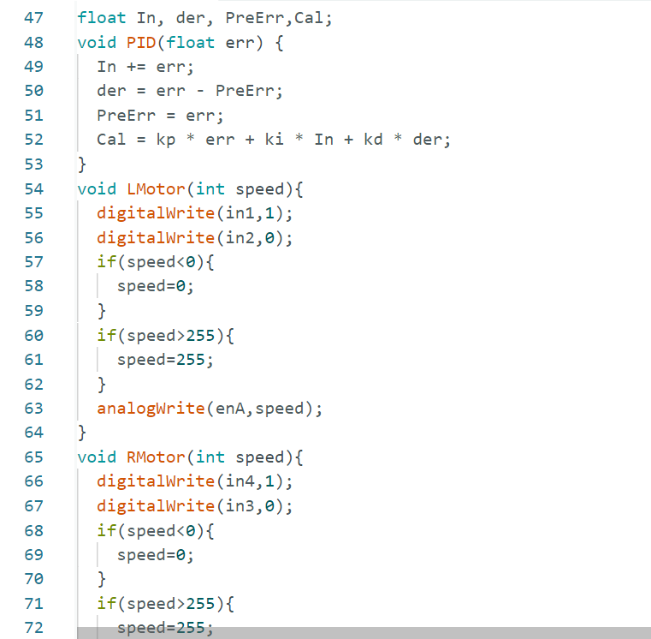
Figure 31: Arduino IDE

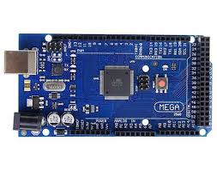
Figure 32: Arduino MEGA2560

The task is completed when the unit test 10 and integration test 1 are done. The unit test 10 is done when the navigating algorithm can keep the chassis on a straight course along a crop row. The integration test 1 is done when the navigating algorithm can keep the full assembly on a straight course along a crop row.

4.4.2 Task 2: Developing CPU for the robotic arm
The second task of objective 3 is to develop and integrate a CPU for the robotic arm utilizing an AI Vision sensor to detect and identify fruits. The CPU will operate the robotic arm allowing the arm to automatically turn all 4 axes to reach out and grasp the fruit then putting the fruit into a container. The programming will be done and be imported into an Raspberry pi 5, see figure 33, based on existing “4 axis robot arm” 19 programming with implementation of the AI vision sensor20.
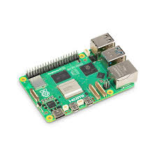
Figure 33: Arduino ESP32

The task is completed when unit test 11 and the integration test 2 are done. The Unit test 11 is done when the 4-axis robotic arm can reliably detect and track the correct fruit and grasp it. The integration test 2 is done when the 4-axis robotic arm (mounted on the chassis) can reliably detect and track the correct fruit and harvest it into the chassis’s basket container.

4.4.3 Task 3: Developing fruit harvesting algorithm
The final task of objective 3 is to combine and integrate the 2 CPUs in task 1 (4.4.1) and task 2 (4.4.2). An “I2C connection” 21 will be established between the 2 Arduinos for communication between the Navigating CPU and the Robotic arm CPU. We’ll develop an algorithm to stop propulsion when a fruit is at the right distance from the AI camera, so that the robotic arm can harvest the fruit, then continue propulsion when all fruits within reach are collected.

The task is completed when integration test 3 the robot can move along a crop row and stop when the AI camera is within the correct distance of the fruit, the robot successfully harvests all fruits within reach and then continues moving along the crop row.

4.4 Objective 4 Unit test and Integration test

4.4.1 Task 1: Unit test

Table 3: Table of Unit Tests
Unit Test number | Description | Date performed | Date completed
1 | Chassis design submission | 21/12/2024 | 21/12/2024
2 | Propulsion design submission | 21/12/2024 | 21/12/2024
3 | Robotic arm design submission | 29/12/2024 | 29/12/2024
4 | Control panel design submission
5 | Completed design submission | 29/12/2024 | 29/12/2024
6 | Chassis and motor assembly test | 6/5/2024 | 6/5/2025
7 | Robotic arm assembly test
8 | Camera assembly test
9 | Control panel, power supply, FC51 IR sensors assembly test | 30/5/2025 | 1/6/2025
10 | Navigating system test | 10/6/2025 | 10/6/2024
11 | Robotic arm’s CPU test
12 | Fruit harvesting algorithm test

4.4.2 Task 2: Integration test

Table 4: Table of Intergration tests
Unit Test number | Description | Date performed | Date completed
1 | Final assembly navigating test
2 | Final assembly robotic arm test
3 | Autonomous fruit harvesting robot test

Chapter 5: Preliminary results

5.1 Objective 1 Task 1: Design the Chassis
After we use TinkerCAD to design the chassis, the result is presented in figure 36. The chassis includes the aluminum frames (A), platforms (B), basket container (C).
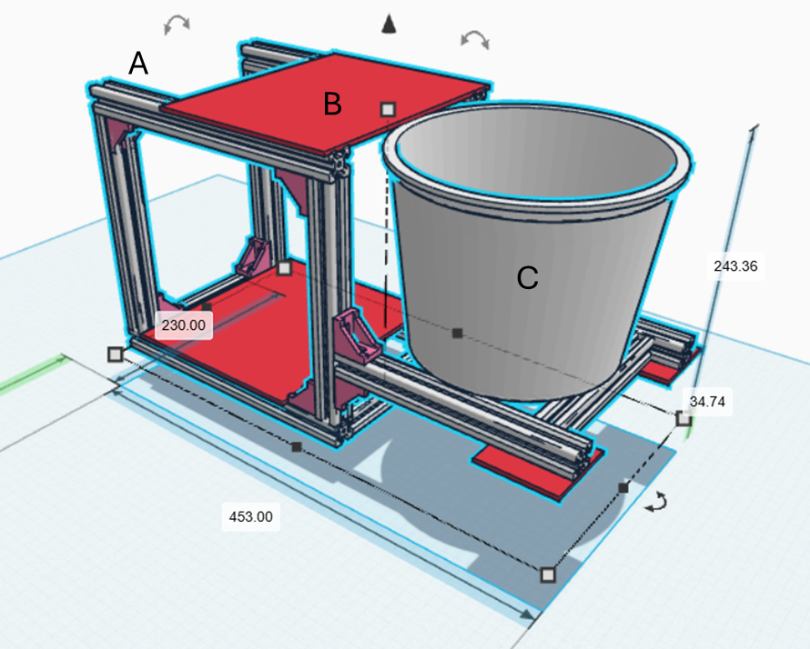
Figure 34: Chassis 3D model in TinkerCAD

5.2 Objective 1 Task 2: Design the Propulsion
After we used TinkerCAD to design the chassis, the result is presented in figure 35. The propulsion includes 1 swivel caster (A), 2 motors (B), and 2 front traction wheels (C).

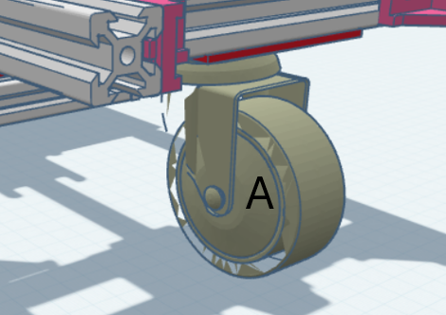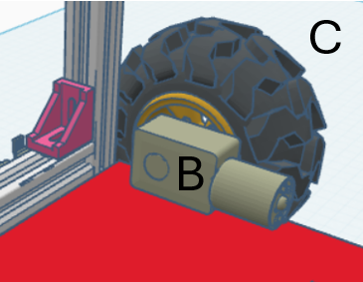
Figure 35: Robot's propulsion

5.3 Objective 1 Task 3: Design the Robotic arm

After we used TinkerCAD to design the arm, the result of the design is presented in figure 36. The arm consists of arm shanks (A), 3 step motors (B), a base (C) and a parallel gripper (D).
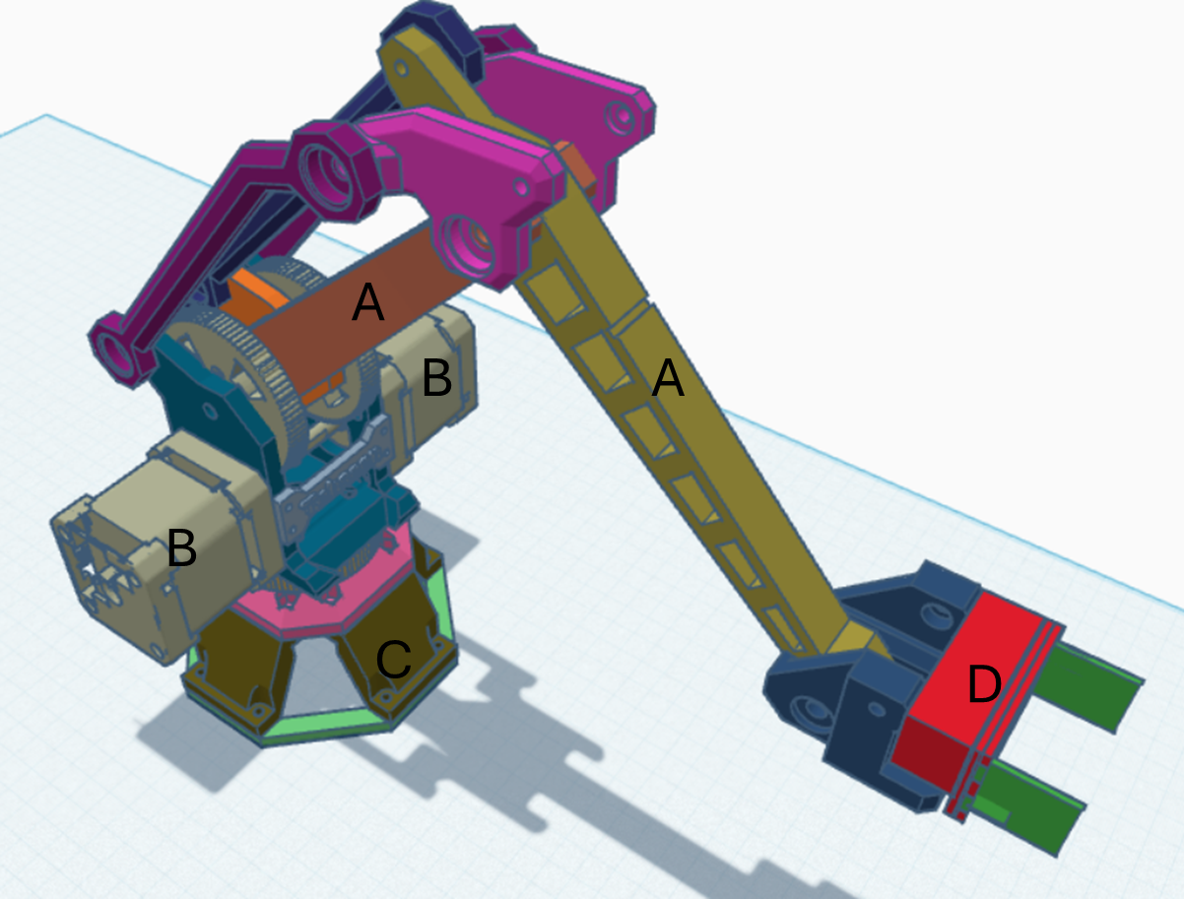
Figure 36: 3D model of robotic arm

5.4 Objective 1 Task 5: Combining the designs
After we used TinkerCAD to combine the designs in task 1, task 2, and task 3. The result of the design is presented in figure 37. The full assembly, consists of the Robotic arm (A) and Chassis (B)

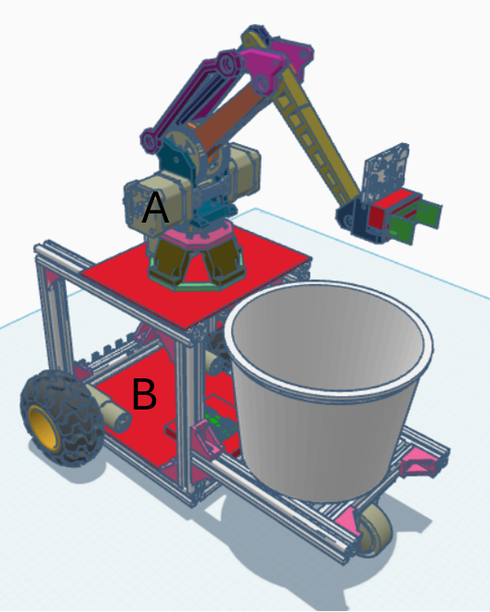
Figure 37: Full assembly in TinkerCAD

5.5 Objective 2 task 1: Assemble the propulsion into the chassis
After we assembled the motors, wheels and mounted them on the chassis. The result is presented in figure 38. The full assembly consists of the Chassis and the Robotic arm.

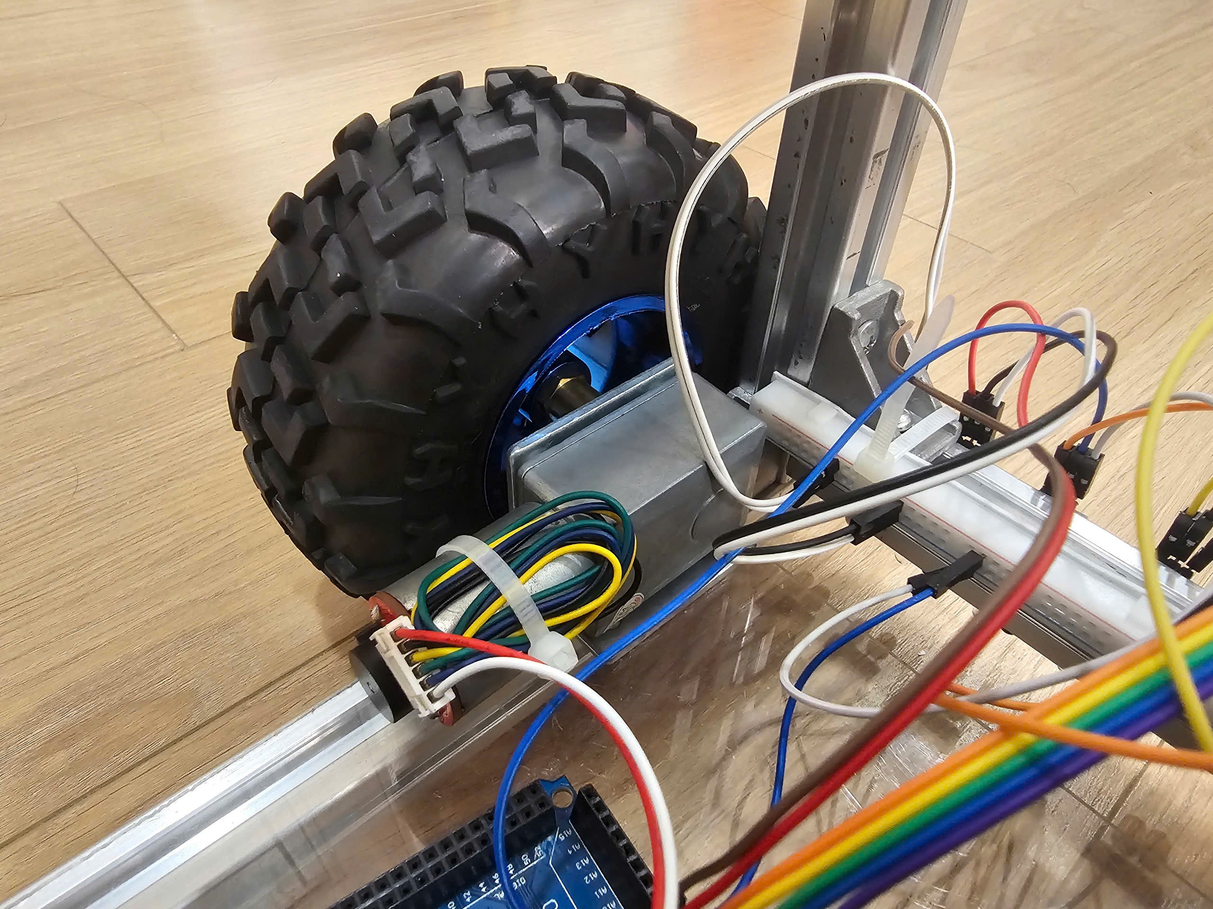

Figure 38: Propulsion assembly
5.6 Objective 2 task 2: Mounting the robotic arm
After we assembled and mounted the robotic arm on the chassis. The result is presented in figure 39. The full assembly consists of the Chassis and the Robotic arm.

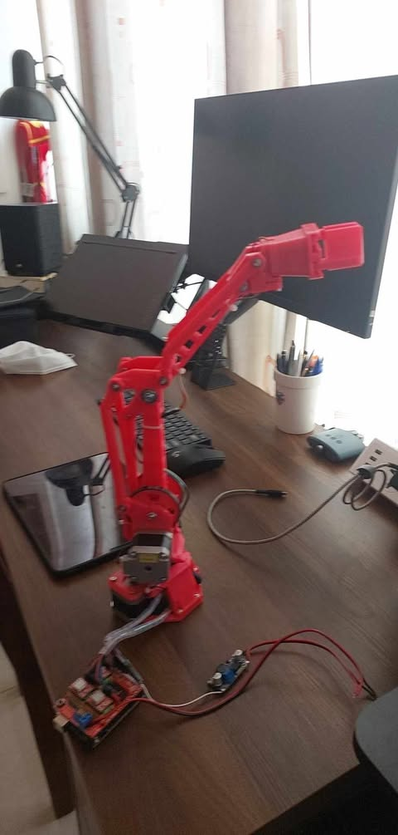
Figure 39: Robotic arm

5.7 Objective 3 task 1: Developing the navigation system.
After we’ve developed the Line Follow algorithm and mounted the IR sensors. The result is presented in figure 40.

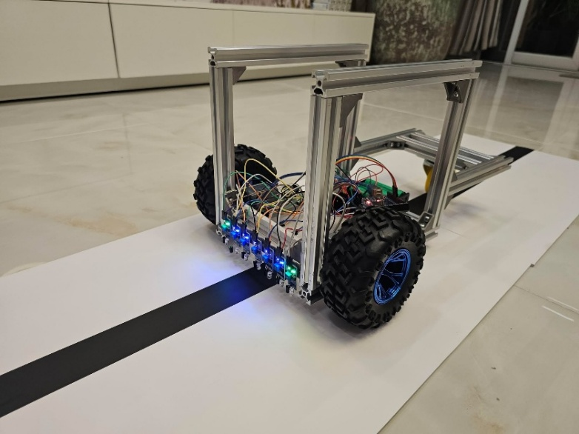
Figure 40: Line follow navigation

5.8 Objective 3 task 2: Developing CPU for the robotic arm.
After we’ve developed the YOLO fruit detection model for the robotic arm’s CPU. The result is presented in figure 41.

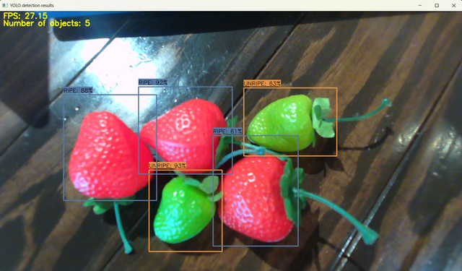
Figure 41: Yolo model test results

REFERENCES
  - “Vietnamese Agriculture before and after Opening Economy”
  - “The intertemporal evolution of agriculture and labor over a rapid structural transformation: Lessons from Vietnam”
  - “Vietnam - Employment In Agriculture (% Of Total Employment)” – Trading Economics
  - https://www.improvingphc.org/vietnam-health-workforce
  - “Phòng ngừa TNLĐ trong nông nghiệp: Nông dân đang “hổng” về kiến thức”
  - “Developing high-tech agricultural workers in the process of industrialization and modernization of agriculture and rural areas” by Assoc. Prof., Dr. NGUYEN SY TRUNG
  - Hien, L. Q., & Kappas, M. (2020). "Impacts of Climate Change on Rice Production in the Mekong Delta of Vietnam." Agricultural Systems, 182, 102856
  - Nguyen, T. B. et al. (2019). "Extreme Weather Events and Their Impact on Agricultural Production in Vietnam." Journal of Climate Change and Health, 1, 100006.
  - Pham, T. T., & Ho, T. M. (2021). "Water Scarcity in Vietnam: Challenges and Solutions for Sustainable Agriculture." Water, 13(4), 549.
  - MARD (Ministry of Agriculture and Rural Development). (2022). "National Strategy for Climate Change Adaptation in Agriculture." Retrieved from MARD official website.
  - “Nông nghiệp Việt Nam: Những vấn đề tồn tại” by VietNam national university of agriculture
  - Korechi, “RoamIO-HCW”
  - Nick Lavars, “Apple harvesting robot plucks a piece of fruit every 7 seconds”, 2021
  - Monash University, “Advanced core processing: New robot technology appealing for apple growers”, 2021
  - Yijie Wang, Yushan Zhou, Lai Wei, Ruiya Li, “Design of a Four-Axis Robot Arm System Based on Machine Vision”, 2023.
  - Pham Van Chinh, Thanh Manh Tuan, Bui Thanh Lam, “Fruit harvesting robot”, 2022
  - “Automated harvesting by a dual-arm fruit harvesting robot”,2022
  - DFrobot, “SEN0305 HUSKEYLENS AI Machine Vision Sensor”
  - Github, “yurecouto/4-axis-robot-code”,2022
  - DFrobot, “Robot Arm controlled by HuskyLens”,2022
  - cornelam, “I2C Between Arduinos”,2022

“Vietnamese Agriculture before and after Opening Economy”
“The intertemporal evolution of agriculture and labor over a rapid structural transformation: Lessons from Vietnam”
“Vietnam - Employment In Agriculture (% Of Total Employment)” – Trading Economics
https://www.improvingphc.org/vietnam-health-workforce
“Phòng ngừa TNLĐ trong nông nghiệp: Nông dân đang “hổng” về kiến thức”
“Developing high-tech agricultural workers in the process of industrialization and modernization of agriculture and rural areas” by Assoc. Prof., Dr. NGUYEN SY TRUNG
Hien, L. Q., & Kappas, M. (2020). "Impacts of Climate Change on Rice Production in the Mekong Delta of Vietnam." Agricultural Systems, 182, 102856
Nguyen, T. B. et al. (2019). "Extreme Weather Events and Their Impact on Agricultural Production in Vietnam." Journal of Climate Change and Health, 1, 100006.
Pham, T. T., & Ho, T. M. (2021). "Water Scarcity in Vietnam: Challenges and Solutions for Sustainable Agriculture." Water, 13(4), 549.
MARD (Ministry of Agriculture and Rural Development). (2022). "National Strategy for Climate Change Adaptation in Agriculture." Retrieved from MARD official website.
“Nông nghiệp Việt Nam: Những vấn đề tồn tại” by VietNam national university of agriculture
Korechi, “RoamIO-HCW”

